1.LOGIN

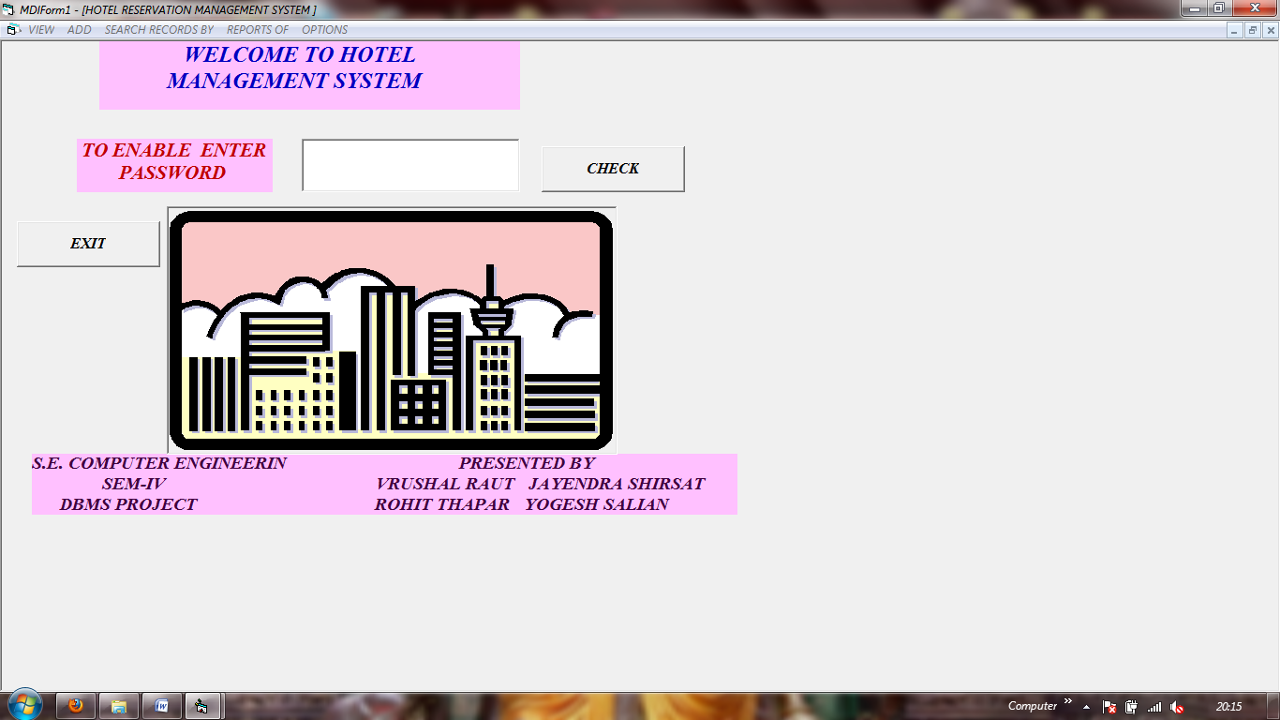

CODE:

Private Sub Command2_Click()

If Text1.Text = Text1.Tag Then

A = MsgBox("RECORDS OF ALLTHE CUSTOMERS OF OUR HOTEL JUST SECONDS AWAY,ENJOY THE TOUR", vbExclamation)

MsgBox "MENU ITEMS ARE ENABLED NOW"

frmSplash.Show

MDIForm1.VIEW.Enabled = True

MDIForm1.REP.Enabled = True

MDIForm1.ADD.Enabled = True

MDIForm1.SEARCH.Enabled = True

MDIForm1.OPT = True

End If

If Text1.Text <> Text1.Tag Then

b = MsgBox("NO NO NO! INVALID PASSWORD. YOU CANNOT CONTINUE", vbCritical, "PASSWORD VALIDATION")

c = MsgBox("TRY ONCE MORE OR EXIT", vbRetryCancel)

If c = vbRetry Then

Text1.SetFocus

Text1.Text = ""

ElseIf c = vbCancel Then

U = MsgBox("BYE,BYE", vbOKOnly)

End

End If

End If

End Sub

Private Sub Form_Load()

MsgBox "IMPORTANT INSTRUCTIONS-PLEASE REFER FORM7 AND THE NOTEPAD FILE ATTACHED TO THIS PROGRAM FOR CORRECT RUNNING OF THIS PROGRAM"

MsgBox "MY EMAIL ADDRESS IS ALSO ON THE NOTEPAD FILE-PLEASE GIVE YOUR SUGGESTIONS"

End Sub

2.MDI:

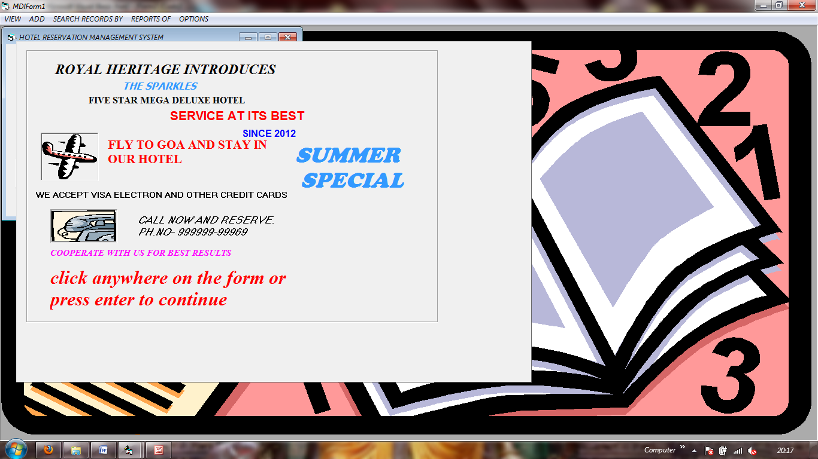

CODE:

***frm.Splash.frm***

Private Sub Form_KeyPress(KeyAscii As Integer)

MDIForm1.Hide

Form3.Show

frmSplash.Hide

End Sub

Private Sub Frame1_Click()

MDIForm1.Hide

Form3.Show

frmSplash.Hide

End Sub

***MDI.frm***

Private Sub ADDTO_Click()

MDIForm1.Hide

ADDTO.Checked = True

ADDTO1.Checked = False

CV.Checked = False

SINGLES(0).Checked = False

ADD.Checked = False

SEARCH.Checked = False

CX(2).Checked = False

SING.Checked = False

REP.Checked = False

re.Checked = False

CUP.Checked = False

Form5.Show

End Sub

Private Sub ADDTO1_Click()

MDIForm1.Hide

ADDTO.Checked = False

ADDTO1.Checked = True

ADDTO.Checked = True

CV.Checked = False

SINGLES(0).Checked = False

ADD.Checked = False

SEARCH.Checked = False

CX(2).Checked = False

SING.Checked = False

REP.Checked = False

re.Checked = False

CUP.Checked = False

Form10.Show

End Sub

Private Sub CAS_Click()

MDIForm1.Arrange vbCascade

End Sub

Private Sub CUP_Click()

MDIForm1.Hide

Form11.Show

CUP.Checked = True

CV.Checked = True

SINGLES(0).Checked = False

ADDTO.Checked = False

ADDTO1.Checked = False

ADD.Checked = False

SEARCH.Checked = False

CX(2).Checked = False

SING.Checked = False

REP.Checked = False

re.Checked = False

End Sub

Private Sub CV_Click()

MDIForm1.Hide

CV.Checked = True

SINGLES(0).Checked = False

ADDTO.Checked = False

ADDTO1.Checked = False

ADD.Checked = False

SEARCH.Checked = False

CX(2).Checked = False

SING.Checked = False

REP.Checked = False

re.Checked = False

CUP.Checked = False

Form6.Show

End Sub

Private Sub CX_Click(Index As Integer)

MDIForm1.Hide

CX(2).Checked = True

ADDTO.Checked = True

ADDTO1.Checked = False

CV.Checked = False

SINGLES(0).Checked = False

ADD.Checked = False

SEARCH.Checked = False

SING.Checked = False

REP.Checked = False

re.Checked = False

CUP.Checked = False

SING.Checked = False

Form8.Show

End Sub

Private Sub report_Click()

MDIForm1.Hide

Form2.Show

End Sub

Private Sub reservation_Click()

MDIForm1.Hide

Form1.Show

End Sub

Private Sub SINGLE_Click(Index As Integer)

MDIForm1.Hide

Form4.Show

End Sub

Private Sub END_Click()

A = MsgBox("ARE YOU SURE DO YOU REALLY WANT TO EXIT", vbInformation + vbYesNo)

If A = vbYes Then

End

End If

End Sub

Private Sub HOR_Click()

MDIForm1.Arrange vbTileHorizontal

End Sub

Private Sub MDIForm_Load()

End Sub

Private Sub re_Click()

MDIForm1.Hide

Form2.Show

re.Checked = True

ADDTO.Checked = True

ADDTO1.Checked = False

CV.Checked = False

SINGLES(0).Checked = False

ADD.Checked = False

SEARCH.Checked = False

CX(2).Checked = False

SING.Checked = False

REP.Checked = False

CUP.Checked = False

CUP.Checked = False

End Sub

Private Sub SING_Click()

MDIForm1.Hide

SING.Checked = True

CX(2).Checked = False

ADDTO.Checked = True

ADDTO1.Checked = False

CV.Checked = False

SINGLES(0).Checked = False

ADD.Checked = False

SEARCH.Checked = False

CX(2).Checked = False

REP.Checked = False

re.Checked = False

CUP.Checked = False

Form4.Show

End Sub

Private Sub SINGLES_Click(Index As Integer)

MDIForm1.Hide

CV.Checked = False

SINGLES(0).Checked = True

ADDTO.Checked = True

ADDTO1.Checked = False

CV.Checked = False

ADD.Checked = False

SEARCH.Checked = False

CX(2).Checked = False

SING.Checked = False

REP.Checked = False

re.Checked = False

CUP.Checked = False

Form1.Show

End Sub

Private Sub VER_Click()

MDIForm1.Arrange vbCascade

End Sub

3.View n Edit record:

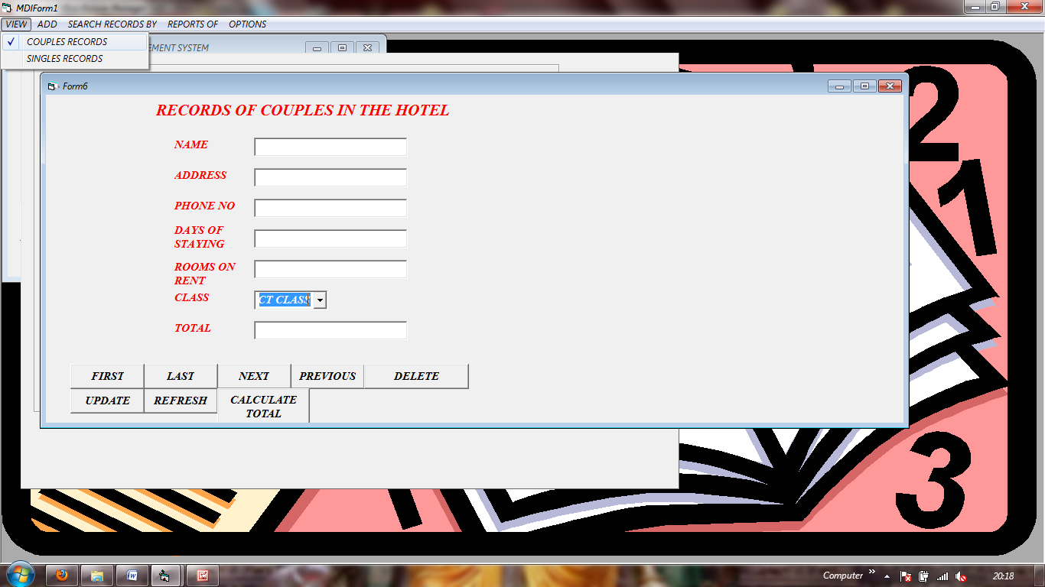

COUPLE record

Form6(COUPLE.frm)

Private Sub CMDEXIT_Click()

A = MsgBox("ARE YOU SURE DO YOU REALLY WANT TO EXIT", vbInformation + vbYesNo)

If A = vbYes Then

End

Else: Form6.Show

End If

End Sub

Private Sub CMDFIRST_Click()

Adodc1.Recordset.MoveFirst

Text1.SetFocus

End Sub

Private Sub CMDLAST_Click()

Adodc1.Recordset.MoveLast

Text1.SetFocus

End Sub

Private Sub CMDNEXT_Click()

Adodc1.Recordset.MoveNext

If Adodc1.Recordset.EOF Then

MsgBox "YOU ARE ALREADY ON THE LAST RECORD"

Adodc1.Recordset.MoveLast

End If

End Sub

Private Sub CMDPREVIOUS_Click()

Adodc1.Recordset.MovePrevious

If Adodc1.Recordset.BOF Then

MsgBox "YOU ARE ALREADY ON THE FIRST RECORD"

Adodc1.Recordset.MoveFirst

End If

End Sub

Private Sub CMDUPDATE_Click()

Adodc1.Recordset.Update

End Sub

Private Sub Command2_Click()

A = MsgBox("ARE YOY SURE TOU WANT TO DELETE", vbYesNo)

If A = vbYes Then

Adodc1.Recordset.Delete

End If

End Sub

Private Sub Command5_Click()

If Combo1.Text = "first" Or Combo1.Text = "FIRST" Then

Text7.Text = (Text5.Text) * (Text4.Text) * 1800

ElseIf Combo1.Text = "second" Or Combo1.Text = "SECOND" Then

Text7.Text = (Text5.Text) * (Text4.Text) * 1000

ElseIf Combo1.Text = "third" Or Combo1.Text = "THIRD" Then

Text7.Text = (Text5.Text) * (Text4.Text) * 800

End If

End Sub

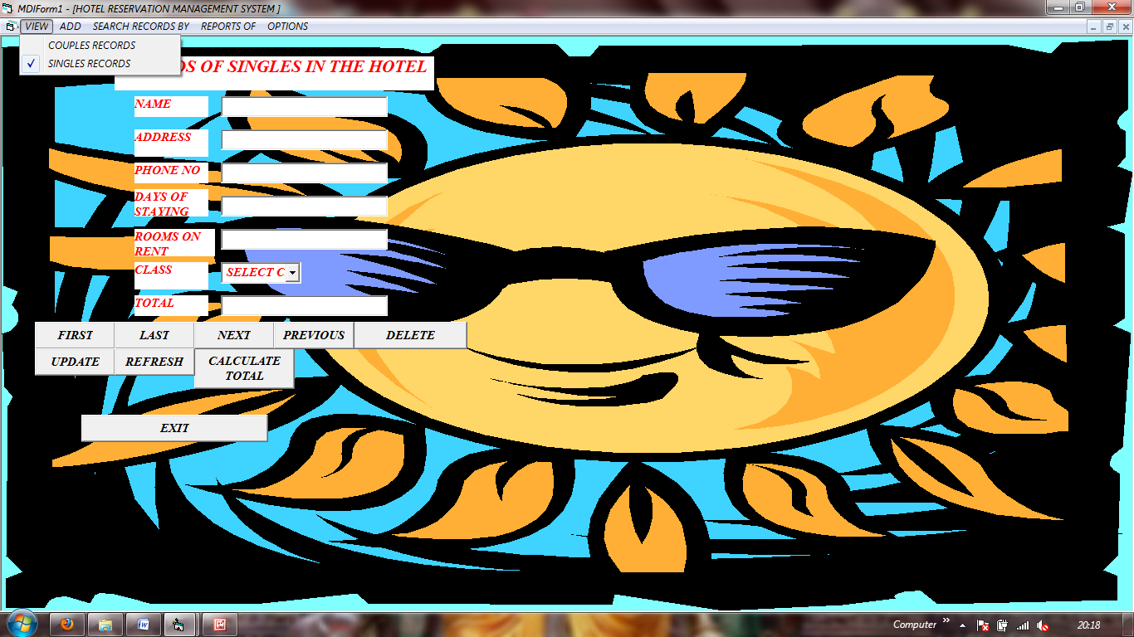

SINGLE record

***Form1(PROJECT IP.frm)***

Dim FIELD

Dim exp

Dim val

Private Sub CMDADDNEW_Click()

Form3.Hide

MDIForm1.Hide

Form5.Show

End Sub

Private Sub CMDDELETE_Click()

End Sub

Private Sub CMDEXIT_Click()

A = MsgBox("ARE YOU SURE DO YOU REALLY WANT TO EXIT", vbInformation + vbYesNo)

If A = vbYes Then

End

Else: Form1.Show

End If

End Sub

Private Sub CMDFIRST_Click()

Adodc1.Recordset.MoveFirst

Text1.SetFocus

End Sub

Private Sub CMDLAST_Click()

Adodc1.Recordset.MoveLast

Text1.SetFocus

End Sub

Private Sub CMDNEXT_Click()

Adodc1.Recordset.MoveNext

If Adodc1.Recordset.EOF Then

MsgBox "YOU ARE ALREADY ON THE LAST RECORD"

Adodc1.Recordset.MoveLast

End If

End Sub

Private Sub CMDPREVIOUS_Click()

Adodc1.Recordset.MovePrevious

If Adodc1.Recordset.BOF Then

MsgBox "YOU ARE ALREADY ON THE FIRST RECORD"

Adodc1.Recordset.MoveFirst

End If

End Sub

Private Sub CMDTOTAL_Click()

Class = Text6.Text

days = val(Text4.Text)

rooms = val(Text5.Text)

If Class = "FIRST" Or Class = "first" Then

total = (rooms * days * 1800)

End If

If Class = "second" Or Class = "SECOND" Then

total = (rooms * days * 1000)

End If

If Class = "third" Or Class = "THIRD" Then

total = (rooms * days * 800)

End If

Text7.Text = total

End Sub

Private Sub CMDUPDATE_Click()

Adodc1.Recordset.Update

End Sub

Private Sub Combo1_Click()

F = Combo1.Text

End Sub

Private Sub Command1_Click()

If Option1.Value = True Then

Form1.Hide

MDIForm1.Hide

Form4.Show

Else

Form1.Hide

MDIForm1.Hide

Form6.Show

End If

End Sub

Private Sub Command2_Click()

A = MsgBox("ARE YOY SURE TOU WANT TO DELETE", vbYesNo)

If A = vbYes Then

Adodc1.Recordset.Delete

End If

End Sub

Private Sub Command3_Click()

val = "'" & Trim(Text9.Text) & "'"

Adodc1.CommandType = adCmdText

Adodc1.RecordSource = ("select * from hotel where ") & FIELD & exp & val

Adodc1.REFRESH

End Sub

Private Sub Command4_Click()

Adodc1.CommandType = adCmdText

Adodc1.RecordSource = "select * from hotel"

Adodc1.REFRESH

End Sub

Private Sub Command5_Click()

If Combo1.Text = "first" Or Combo1.Text = "FIRST" Then

Text7.Text = (Text5.Text) * (Text4.Text) * 1800

ElseIf Combo1.Text = "second" Or Combo1.Text = "SECOND" Then

Text7.Text = (Text5.Text) * (Text4.Text) * 1000

ElseIf Combo1.Text = "third" Or Combo1.Text = "THIRD" Then

Text7.Text = (Text5.Text) * (Text4.Text) * 800

End If

End Sub

Private Sub Text9_Change()

val = Text9.Text

End Sub

Private Sub Form_Load()

End Sub

Private Sub REFRESH_Click()

Adodc1.CommandType = adCmdText

Adodc1.RecordSource = "select * from hotel"

Adodc1.REFRESH

End Sub

4.ADD RECORD FOR SINGLE

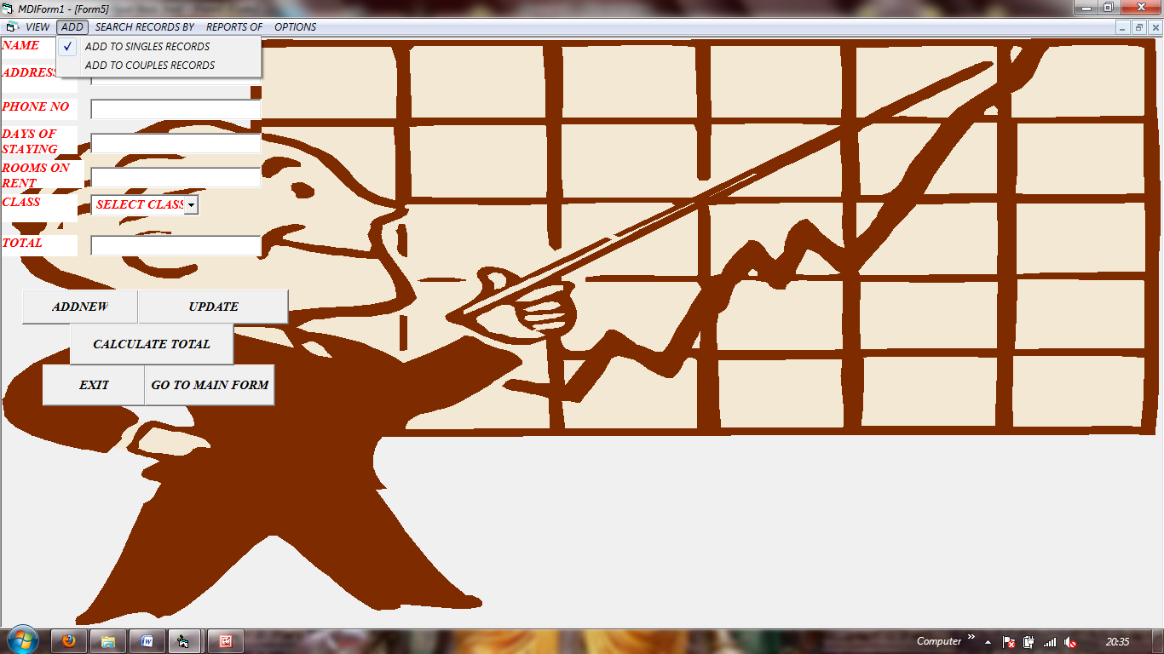

FORM5(FORM5.frm)

Private Sub CMDADDNEW_Click()

Adodc1.Recordset.AddNew

Text1.SetFocus

End Sub

Private Sub CMDUPDATE_Click()

'Adodc2.Recordset.Update

Adodc1.Recordset.Update

End Sub

Private Sub Command1_Click()

If Combo1.Text = "first" Or Combo1.Text = "FIRST" Then

Text7.Text = (Text5.Text) * (Text4.Text) * 1800

ElseIf Combo1.Text = "second" Or Combo1.Text = "SECOND" Then

Text7.Text = (Text5.Text) * (Text4.Text) * 1000

ElseIf Combo1.Text = "third" Or Combo1.Text = "THIRD" Then

Text7.Text = (Text5.Text) * (Text4.Text) * 800

End If

End Sub

Private Sub Command2_Click()

A = MsgBox("ARE YOU SURE DO YOU REALLY WANT TO EXIT", vbInformation + vbYesNo)

If A = vbYes Then

End

Else: Form5.Show

End If

End Sub

Private Sub Command5_Click()

MDIForm1.Hide

Form1.Show

End Sub

Private Sub Form_Load()

End Sub

Private Sub Text3_KeyPress(KeyAscii As Integer)

'If Not (KeyAscii >= Asc("0") And KeyAscii <= Asc("A")) Then

'KeyAscii = 0

'A = MsgBox("NUMBERS ONLY", vbCritical)

'Text1.Text = ""

'Text1.SetFocus

'End If

End Sub

Private Sub Text4_KeyPress(KeyAscii As Integer)

'If Not (KeyAscii >= 0 Or KeyAscii <= 10) Then

'A = MsgBox("NUMBERS ONLY", vbCritical)

'Text34.Text = ""

'Text4.SetFocus

'End If

End Sub

Private Sub Text5_KeyPress(KeyAscii As Integer)

'If Not (KeyAscii >= 0 Or KeyAscii <= 10) Then

'A = MsgBox("NUMBERS ONLY", vbCritical)

'Text5.Text = ""

'Text5.SetFocus

End Sub

Private Sub Text6_KeyPress(KeyAscii As Integer)

'If (KeyAscii >= 0 Or KeyAscii <= 10) Then

'A = MsgBox("ALPHABETS ONLY", vbCritical)

'Text6.Text = ""

'Text6.SetFocus

End Sub

Private Sub Text7_KeyPress(KeyAscii As Integer)

'If Not (KeyAscii >= 0 Or KeyAscii <= 10) Then

'A = MsgBox("NUMBERS ONLY", vbCritical)

'Text7.Text = ""

'Text7.SetFocus

End Sub

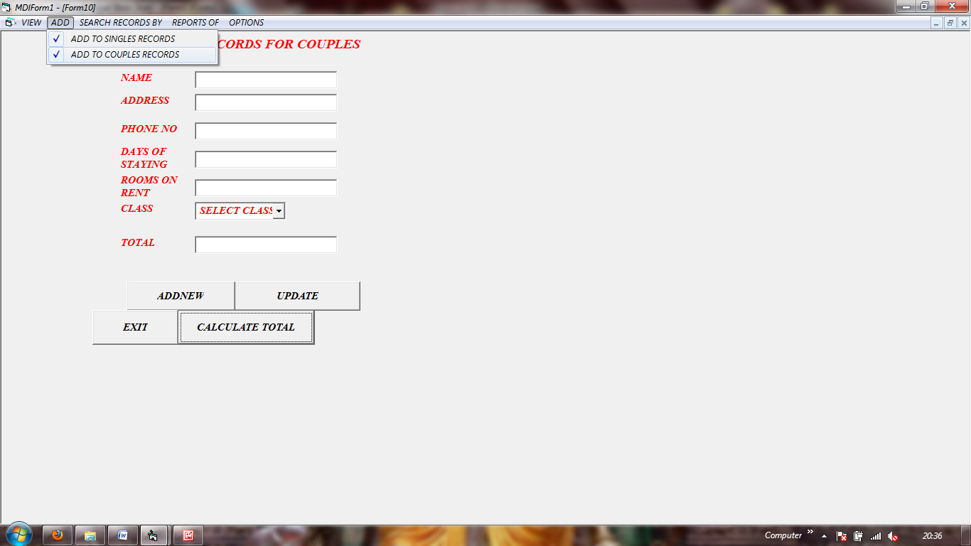

***Form10(Form10.frm)***

Private Sub CMDADDNEW_Click()

Adodc1.Recordset.AddNew

Text1.SetFocus

End Sub

Private Sub CMDUPDATE_Click()

Adodc1.Recordset.Update

End Sub

Private Sub Command1_Click()

If Combo1.Text = "first" Or Combo1.Text = "FIRST" Then

Text7.Text = (Text5.Text) * (Text4.Text) * 1800

ElseIf Combo1.Text = "second" Or Combo1.Text = "SECOND" Then

Text7.Text = (Text5.Text) * (Text4.Text) * 1000

ElseIf Combo1.Text = "third" Or Combo1.Text = "THIRD" Then

Text7.Text = (Text5.Text) * (Text4.Text) * 800

End If

End Sub

Private Sub Command2_Click()

A = MsgBox("ARE YOU SURE DO YOU REALLY WANT TO EXIT", vbInformation + vbYesNo)

If A = vbYes Then

End

Else: Form5.Show

End If

End Sub

Private Sub Form_Load()

End Sub

**5.SEARCH record**

**COUPLE**

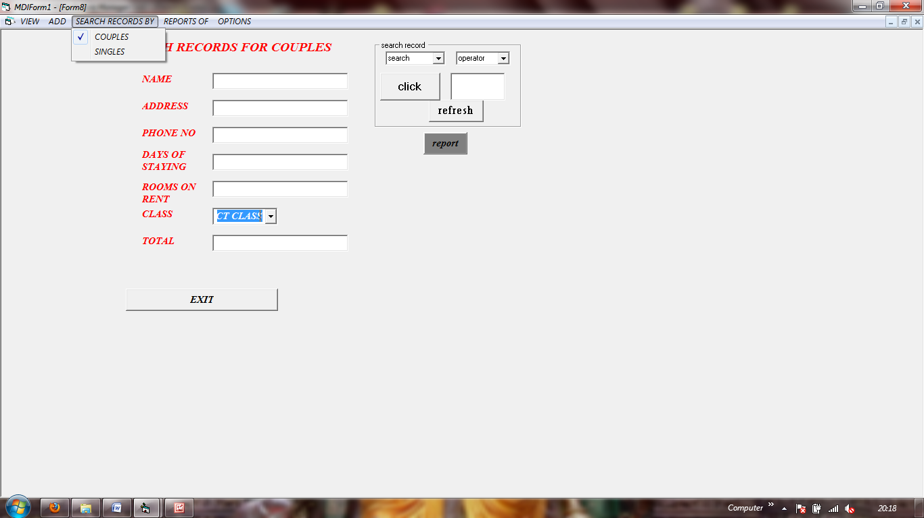

***Form8(CCC.frm)***

Dim FIELD

Dim exp

Dim val

Private Sub CMDEXIT_Click()

A = MsgBox("ARE YOU SURE DO YOU REALLY WANT TO EXIT", vbInformation + vbYesNo)

If A = vbYes Then

End

Else: Form8.Show

End If

End Sub

Private Sub Combo2_Change()

Text9.Text = ""

End Sub

Private Sub Command3_Click()

val = "'" & Trim(Text9.Text) & "'"

Adodc1.CommandType = adCmdText

Adodc1.RecordSource = ("select * from COUPLE where ") & FIELD & exp & val

Adodc1.REFRESH

End Sub

Private Sub Command4_Click()

Adodc1.CommandType = adCmdText

Adodc1.RecordSource = "select * from COUPLE"

Adodc1.REFRESH

End Sub

Private Sub Combo3_Click()

exp = Combo3.Text

End Sub

Private Sub Combo2_Click()

FIELD = Combo2.Text

Text9.Text = ""

End Sub

Private Sub Form_Load()

End Sub

**SINGLE**

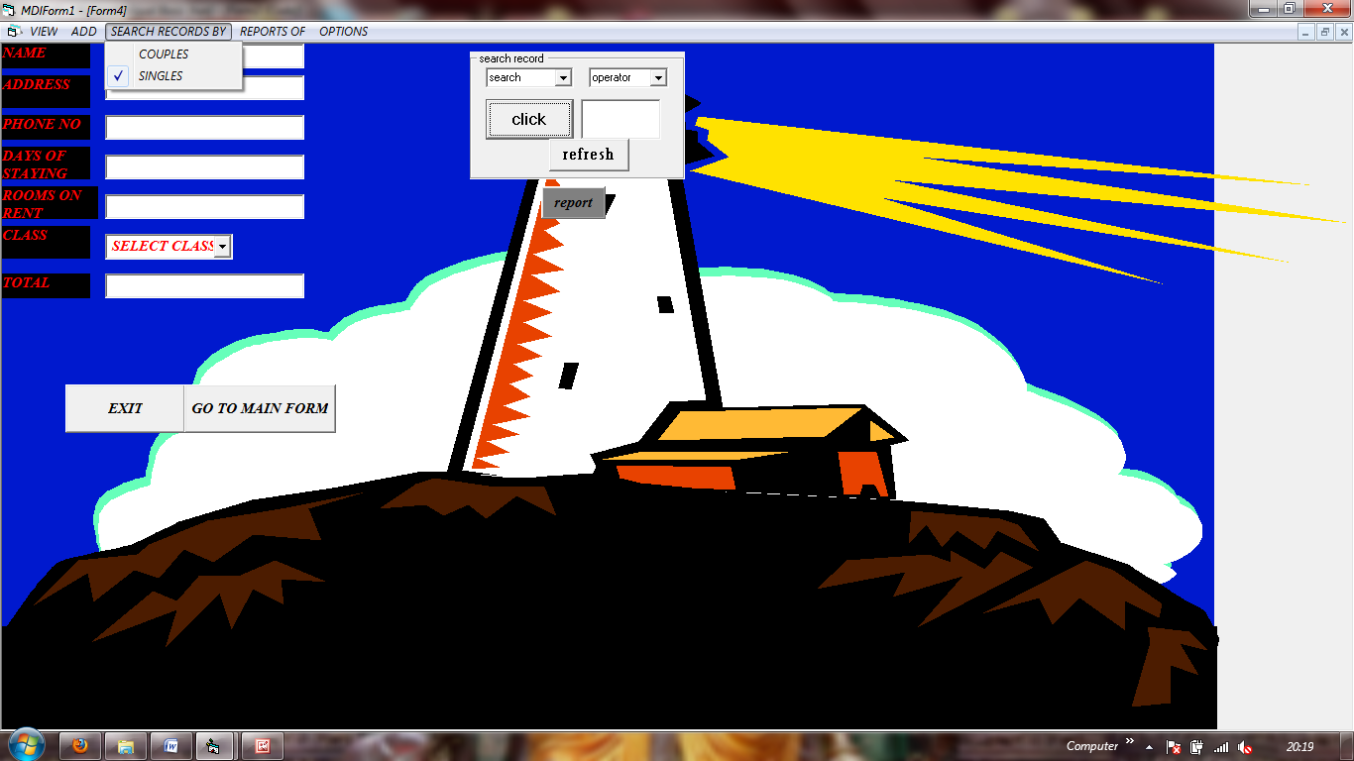

***Form4(Form4.frm)***

Dim FIELD

Dim exp

Dim val

Private Sub Combo1_Click()

FIELD = Combo1.Text

End Sub

Private Sub Combo2_Click()

exp = Combo2.Text

End Sub

Private Sub Command1_Click()

MDIForm1.Hide

Form2.Show

End Sub

Private Sub Command2_Click()

A = MsgBox("ARE YOU SURE DO YOU REALLY WANT TO EXIT", vbInformation + vbYesNo)

If A = vbYes Then

End

Else: Form4.Show

End If

End Sub

Private Sub Command3_Click()

val = "'" & Trim(Text9.Text) & "'"

Adodc1.CommandType = adCmdText

Adodc1.RecordSource = ("select * from hotel where ") & FIELD & exp & val

Adodc1.REFRESH

End Sub

Private Sub Command4_Click()

Adodc1.CommandType = adCmdText

Adodc1.RecordSource = "select * from hotel"

Adodc1.REFRESH

End Sub

Private Sub Command5_Click()

MDIForm1.Hide

Form1.Show

End Sub

Private Sub Form_Load()

End Sub

6.DATA SHEET(DATA GRID):SINGLE ADODB1/2 GRID

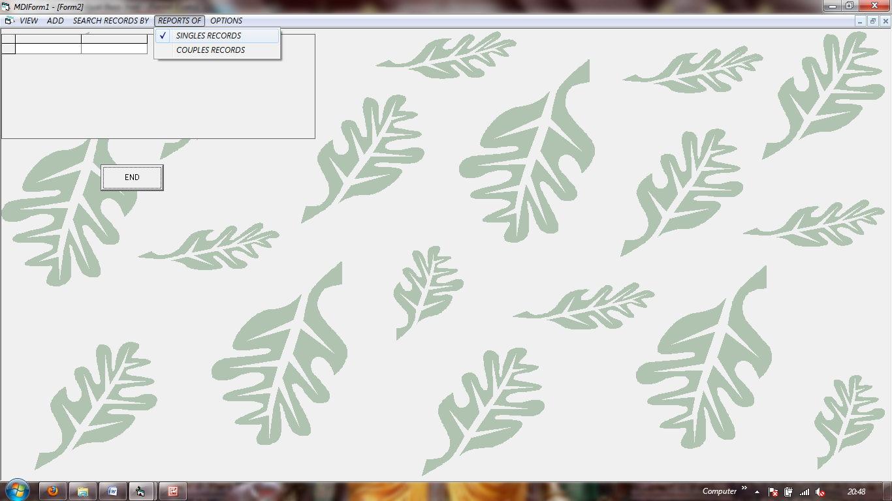Form2(form2.frm)

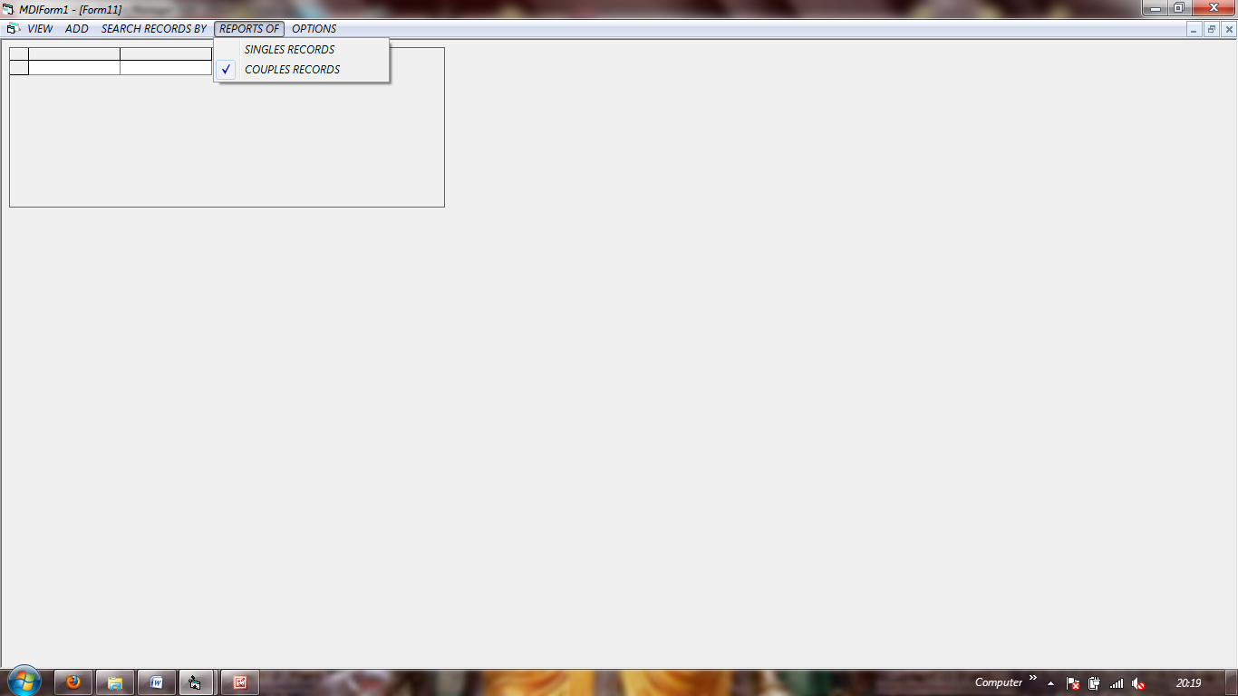COUPLE ADODB2/2 GRID :

Form11(form11.frm)